Student Ridership Social Media Templates

FACEBOOK EXAMPLE 1:

INSERT SCHOOL OR DISTRICT is launching an innovative app to keep your children safer! With @HereComestheBus, you will receive alerts when your child got on the right bus and off at the right stop.

The app is FREE to all parents for the 2016-17 school year. Download the #HereComestheBus app from the App Store or Google Play.

To learn more, visit http://www.herecomesthebus.com.

(ADD HERE COMES THE BUS IMAGE)
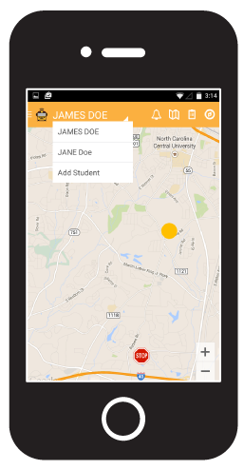

FACEBOOK EXAMPLE 2:

INSERT SCHOOL OR DISTRICT just announced that starting INSERT DATE, it will offer you an innovative website and app, @HereComestheBus. Through it, you can push notifications or email alerts when and where your child gets on and off the bus.

To learn more, visit www.herecomesthebus.com.
(ADD HERE COMES THE BUS IMAGE)

TWITTER EXAMPLE 1:
Download the @HereComestheBus app to know when your child got on or off the bus. #RightBusRightStopRightTime

TWITTER EXAMPLE 2:

@HereComesTheBus will send an alert when your child gets on/off the bus. #PeaceofMind! Download the app today! #AppStoreGooglePlay

TWITTER EXAMPLE 3:

Know if your child got on or off the bus? With @HereComstheBus you can! Visit herecomesthebus.com to learn more #LessStress

