Here Comes the Bus Social Media Templates

FACEBOOK EXAMPLE 1:

INSERT SCHOOL OR DISTRICT is launching an innovative app to keep your children safer and make your morning easier. With @HereComestheBus, you and your child will receive alerts when the bus is near!

The app is FREE to all parents for the 2016-17 school year. Download the #HereComestheBus app from the App Store or Google Play.

To learn more, visit www.herecomesthebus.com/.

(ADD HERE COMES THE BUS IMAGE)
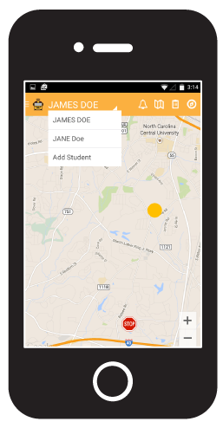

FACEBOOK EXAMPLE 2:

INSERT SCHOOL OR DISTRICT just announced that starting INSERT DATE, it will offer you and your child an innovative website and app, @HereComestheBus. Through it, you can view the real-time location of your child’s school bus and receive push notifications or email alerts when your child’s bus is near or has been substituted.

To learn more, visit www.herecomesthebus.com.
(ADD HERE COMES THE BUS IMAGE)

TWITTER EXAMPLE 1:
Download the @HereComestheBus app to know when your child’s bus is near! #StressLess

TWITTER EXAMPLE 2:

@HereComestheBus will send you an alert when your child’s bus is near! Check out herecomesthebus.com

TWITTER EXAMPLE 3:

Know if your child’s school bus is on time, late, or early, and when it arrives at and leaves school with @HereComestheBus #LessStress

TWITTER EXAMPLE 4:
Need to get your child off the bus in the afternoon? @HereComestheBus can help with that! Download the app on the #AppStore or #GooglePlay

