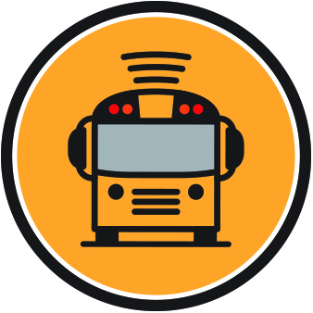
Here Comes the Bus®
Now available to parents of (INSERT SCHOOL NAME) students

• View the real-time location of your child’s bus
• Access the app from your smartphone, tablet or computer
• Receive push notifications or email alerts
• Send your child to the bus stop at the just right time,
every time
How to get started:
1. Download the Here Comes the Bus app* or visit herecomesthebus.com
2. Click the button
3. Enter school code (INSERT ACCOUNT #) and click “Next” followed by “Confirm”
4. Complete the “User Profile” box
5. Under “My Students,” click “Add.” Enter your child’s last name and student ID number
6. Once you confirm your information, you’re ready to begin using Here Comes the Bus!

*Available at the App Store and Google Play
Here Comes the Bus® is a registered trademark of Synovia Solutions™ LLC
Here Comes the Bus®
Now available to parents of (INSERT SCHOOL NAME) students

• View the real-time location of your child’s bus
• Access the app from your smartphone, tablet or computer
• Receive push notifications or email alerts
• Send your child to the bus stop at the just right time,
every time
How to get started:
1. Download the Here Comes the Bus app* or visit herecomesthebus.com
2. Click the button
3. Enter school code (INSERT ACCOUNT #) and click “Next” followed by “Confirm”
4. Complete the “User Profile” box
5. Under “My Students,” click “Add.” Enter your child’s last name and student ID number
6. Once you confirm your information, you’re ready to begin using Here Comes the Bus!

*Available at the App Store and Google Play
Here Comes the Bus® is a registered trademark of Synovia Solutions™ LLC

