Bus Pass
(via Here Comes the Bus®)
Now available to students of (INSERT SCHOOL NAME)

• Use a barcode ID on your smartphone to scan on/off the bus

How to get started:
1. Download the Here Comes the Bus app*
2. Click the Bus Pass button
3. Enter last name, ID and school code (INSERT ACCOUNT #)
4. When barcode appears, hold under scanner until high-pitch beep occurs, indicating scan is successful
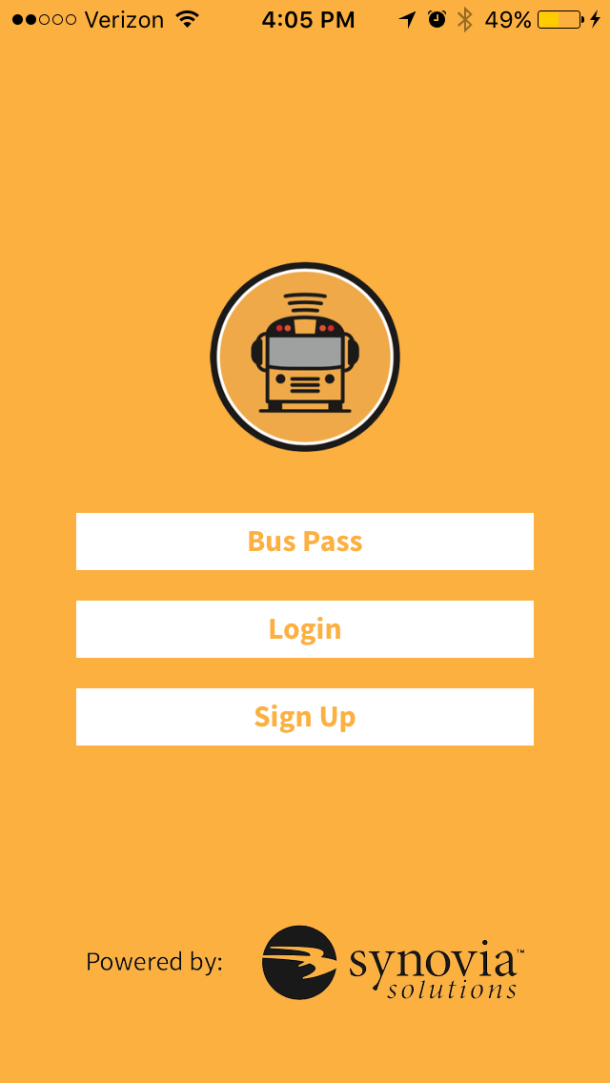

*Available at the App Store and Google Play
Here Comes the Bus® is a registered trademark of Synovia Solutions™ LLC
Bus Pass
(via Here Comes the Bus®)
Now available to students of (INSERT SCHOOL NAME)

• Use a barcode ID on your smartphone to scan on/off the bus

How to get started:
1. Download the Here Comes the Bus app*
2. Click the Bus Pass button
3. Enter last name, ID and school code (INSERT ACCOUNT #)
4. When barcode appears, hold under scanner until high-pitch beep occurs, indicating scan is successful

*Available at the App Store or Google Play
Here Comes the Bus® is a registered trademark of Synovia Solutions™ LLC

